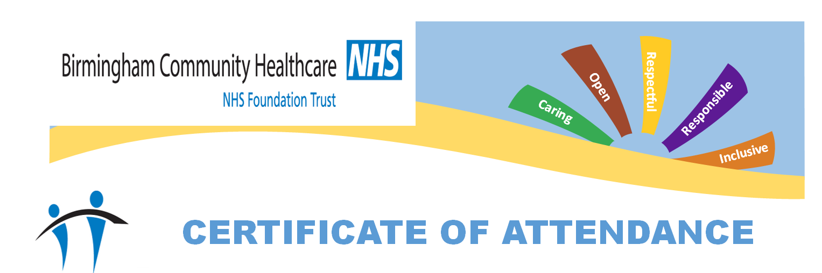

This is to certify that staff at

JAMES BRINDLEY

Have attended.

EPILEPSY AWARENESS TRAINING

Trainer: Jeanette Challenor RN

Date: 16/03/2026

