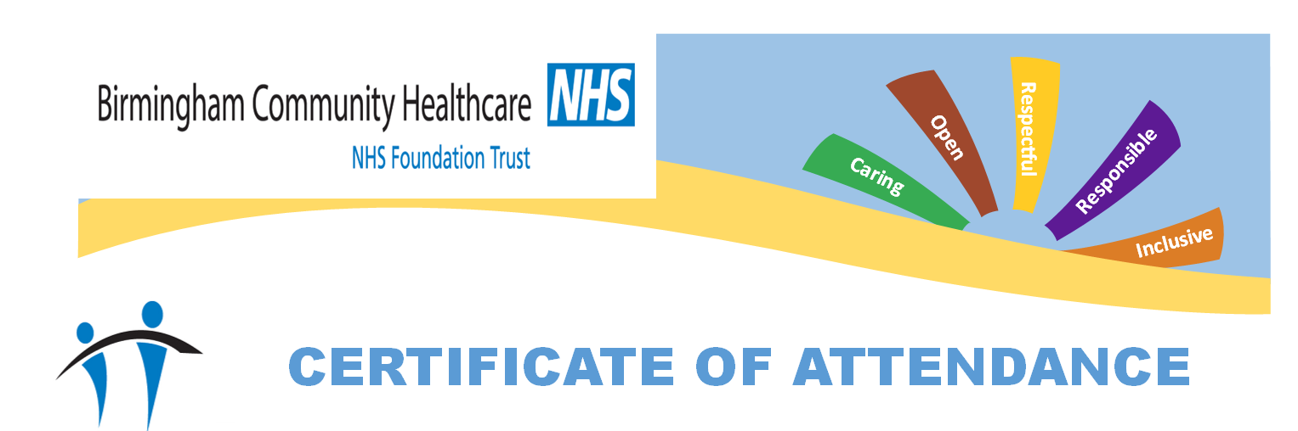

This is to certify that staff at

JAMES BRINDLEY

Have attended.

ALLERGY/ANAPHYLAXIS AWARENESS AND ASTHMA AWARENESS TRAINING

Trainer: Jeanette Challenor RN

Date: 10/11/2025



