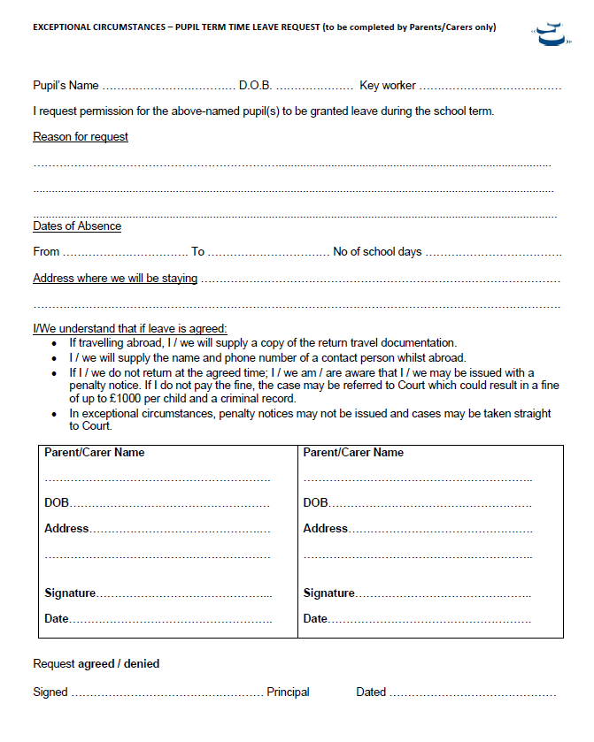
Appendix 5: Exceptional Circumstances Form

